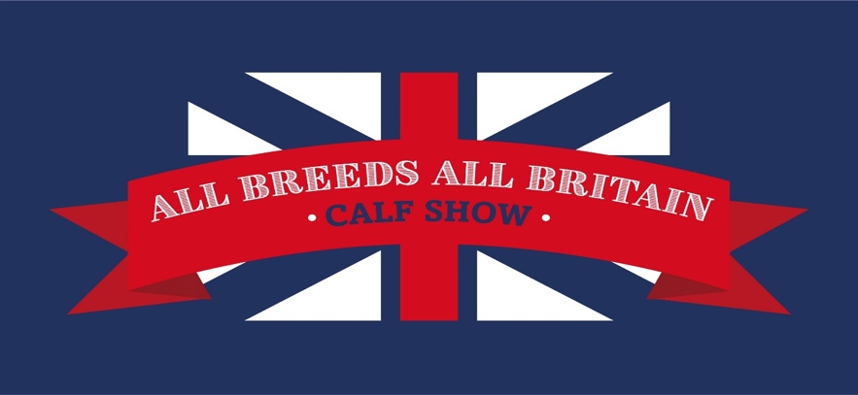

ALL BREEDS ALL BRITAIN CALF SHOW 2026

Friday 30th October – Sunday 1st November

Staffordshire County Showground, ST18 0BD

COLOURED BREEDS ENTRY FORM

ENTRIES TO BE RECEIVED BY BREED SOCIETIES BY
MONDAY 12th OCTOBER 2026
All Entries to be submitted on official entry forms (one per breed), please indicate if you have entered more than one coloured breed, if you wish for them to be stalled together

Please forward entry forms and fees to the relevant Breed Society, headed All Breeds All Britain Calf Show 2026:

AYRSHIRE: Ayrshire Cattle Society, Holme House, Dale, Ainstable, Carlisle, Cumbria CA4 9RH
Registrations@ayrshirescs.org

BRITISH FRIESIAN: Lizzie Yates, Scope House, Hortonwood 33, Telford, Shropshire TF1 7EX
lizzieyates@ukcows.com

BROWN SWISS: Brown Swiss Society, Pedigree Livestock Services, Holme House, Ainstable, Carlaise, Cumbria, CA4 9RH
office@brownswiss.org

DAIRY SHORTHORN: Pedigree Livestock Services, Holme House, Dale, Ainstable, Carlisle, Cumbria CA4 9RH
breedsecretary@shorthorn.co.uk

GUERNSEY: Helen Cox, White Lodge, Rickeston, Milford Haven, SA73 3TJ
office@guernseycattle.com

JERSEY: Jersey Cattle Society, Holme House, Dale, Ainstable, Carlisle, Cumbria CA4 9RH
office@thejcs.uk

SHOWMANSHIP CLASSES – FOC ENTRY

CLASS NUMBER

Name

DOB

Breed

CLASS NUMBER

Name

DOB

Breed

CLASS NUMBER

Name

DOB

Breed

CLASS NUMBER

Name

DOB

Breed

CLASS NUMBER

Name

DOB

Breed

CLASS NUMBER

Name

DOB

Breed

CALF CLASSES - £30 PER ENTRY (all Breeds)

Breed Exhibitor .
More than one breed entered Yes/No Breeds to be stalled together Yes/No
E-Mail Mobile number .
Contact at show .

CLASS NUMBER
Name Ear tag no
Sire Dam
DOB Exhibitor bred YES/NO

CLASS NUMBER
Name Ear tag no
Sire Dam
DOB Exhibitor bred YES/NO

CLASS NUMBER
Name Ear tag no
Sire Dam
DOB Exhibitor bred YES/NO

CLASS NUMBER
Name Ear tag no
Sire Dam
DOB Exhibitor bred YES/NO

CLASS NUMBER
Name Ear tag no
Sire Dam
DOB Exhibitor bred YES/NO

CLASS NUMBER
Name Ear tag no
Sire Dam
DOB Exhibitor bred YES/NO

CLASS NUMBER
Name Ear tag no
Sire Dam
DOB Exhibitor bred YES/NO

CLASS NUMBER
Name Ear tag no
Sire Dam
DOB Exhibitor bred YES/NO

CLASS NUMBER
Name Ear tag no
Sire Dam
DOB Exhibitor bred YES/NO

CLASS NUMBER
Name Ear tag no
Sire Dam
DOB Exhibitor bred YES/NO
I hereby certify that the contents herein is correct to the best of my knowledge and belief, and I hereby agree to conform to and abide by the showing rules and regulations of the relevant Society, which have been read prior to me signing this form, together with the show rules as stated in the schedule.

PREFIX:

BREED SOCIETY:

NAME:

SIGNATURE:

DATE:

